Celebration with cake (online cake purchase)
Software Requirements Specification

Version 1.0



Group Id: S18023267F
Supervisor Name : ShafaqNisar

Revision History
Date (dd/mm/yyyy) | Version | Description | Author
01/05/2018 | 1.0 | ONLINE CAKE PURCHASE SYSTEM is a website designed primarily for use in the cake delivery industry. This system will allow hotels and restaurants to increase scope of business by reducing the labor cost involved. The system also allows to quickly and easily manage an online menu which customers can browse and use to place orders with just few clicks. And it makes possible for every customer to buy cake on his own requirement ,size and taste in by providing him different categories of it. | ( S18023267F)  Mc160200945

Table of Contents

- Scope (of the project)
- Functional Requirements Non Functional requirements
- Use Case Diagram
- Usage Scenarios
- Adopted Methodology
- Work Plan (Use MS Project to create Schedule/Work Plan)

SRS Document

Scope of Project:

Online cake purchase system ensures to provide an interactive website that facilitates the customers to experience and buy the Cake on-the-click Functionality which enables them to buy any of the cake items through online cake purchase system. Different categories of cake will be provided in it such as cake size and flavor. Once user wishes to checkout he/she must register on the website first. The customer will login the account and after logging in he /she can buy the product of his own desire. The customer can confirm the order or he can cancel the order if he desires to cancel it. After the confirmation of the order the payment will be made in cash through customer and he will successfully buy his required item.

Functional and non Functional Requirements:

Functional Requirements:-
Online cake purchase store will provide the followings functions to the user and admin of the system.
1 .Admin:
- accept order
- delete order
- edit order
- Sale Record
- Delete cake category/size
- Add cake category/size
2. Customer
a) Sign-in
b) Create an Account
c) Search cake category/size
d) Select cake category/size
e) Buy cake
f) Confirm order and Delete Order.
3. Catalogue
- new cake category/size
- editing the existing cake category/size
- delete cake category/size
Non-Functional Requirement
- Online cake purchase system will be enable to create customers
- It will help to delete customers
- It can work on Windows, Mac, Linux and different mobile devices.
- It will provide security

Use Case Diagram(s):

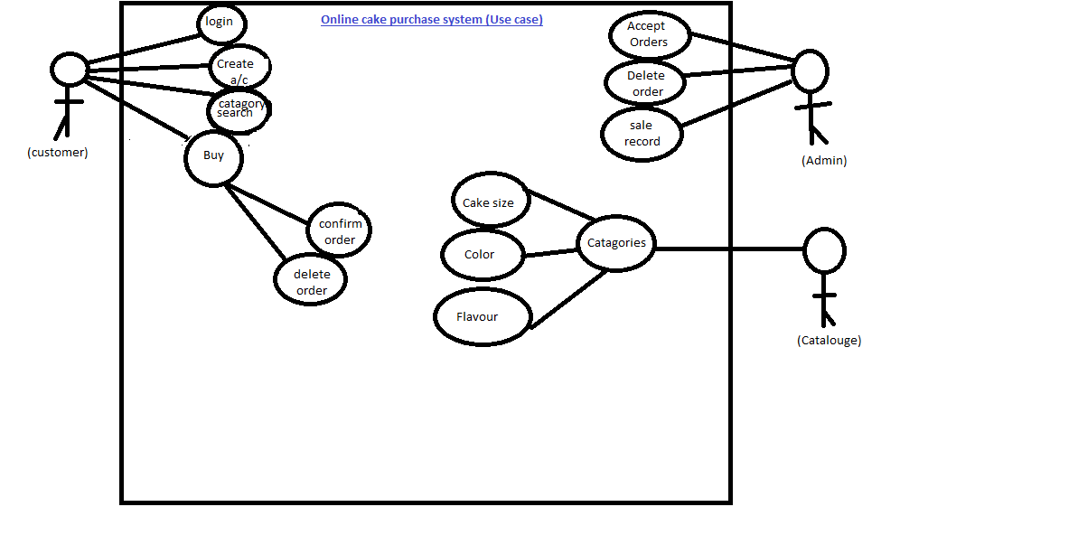

Usage Scenarios:

Use case title |  | Customer
Use case id |  | OCPS-FR-1
Actions |  | - Customer will login the account.  - After getting successfully login he will search his desire product  - Different categories will be available there for having desire Cake such as size, color and flavored etc.  - The customer will end up with purchasing the cake online.
Alternative paths |  | N/A
Description |  | Online cake purchase system will allow the customers to buy Cake of their desire so they don’t have to go anywhere and all the purchase will happen to be online.
Pre- conditions |  | Customer should login the system.
Post-condition | User has successfully purchased the Cake online.
Author | S18023267F (Mc160200945)
Exception | When the user will enter wrong id or password then exception of invalid id or password will be come

Use case Scenario
Use case title |  | Admin
Use case id |  | UC2
Actions |  | - Admin will accept the orders  - Admin will took the sale records  - Admin can delete orders
Alternative paths |  | N/A
Description |  | Admin controls the system in a sequential way.
Pre- conditions |  | Admin should be present to make the purchase possible
Post-condition | Admin has successfully performed his functions.
Author | S18023267F(MC160200945)
Exception | If admin will not be present there then so many tasks will be stay on pending.

Use case Scenario
Use case title |  | Catalogue
Use case id |  | UC3
Actions |  | Catalogue provides different categories related to Cake Such as:-  - Color  - Size  - Flavor
Alternative paths |  | N/A
Description |  | Catalogue provides the criteria to its customers that enable them the Quality of the Cake that they are buying online.
Pre- conditions |  | Catalogue should be precise that clears the sense of buying the product for customers .
Post-condition | Catalogue has successfully provided the desired information to its customers.
Author | S18023267F(MC160200945)
Exception | If the information of the product in the catalogue is not sufficient then it can be difficult for the customers of getting desired product.

Adopted Methodology

VU Process Model
For making our software we adopted VU Process Model which is a combination of waterfall and spiral models. The idea behind this model is that to get the benefits of both these models.

Requirement Analysis & Definition:
All possible requirements of the system to be developed are captured in this phase. We will define the functional, non functional requirements in this phase. These requirements are analyzed for their validity and the possibility of incorporating the requirements in the system to be development is also studied. Finally, a Requirement Specification document is created which serves the purpose of guideline for the next phase of the model, in which we define the use cases for our system and their scenarios here too.

Risk analysis & Work Plan:
In this phase we will be defining time line in which this project should be completed, the cost which will be allocated for our project and all the basic planning activities will be done in this phase. All possible risks associated with the project are identified and analyzed here. The aim is that all risks are resolved.

System Design
In this phase we will understand what we are going to create and what it should look like? The requirement specifications from first phase will be studied in this phase and system design will be prepared. System Design
Helps in specifying hardware and system requirements and also helps in defining overall system architecture.

Implementation
This step consists of actually constructing the product as per the design specification(s) developed in the previous step. Typically, this step is performed by a development team consisting of programmers, interface designers and other specialists, using tools such as compilers, debuggers, interpreters and media editors.

Verification/Testing
In this phase we will verify and test our system. We will perform different type of testing here and if got some problem, we will solve that out. There are mostly three steps of testing….
i) unit testing
ii) system testing
iii) acceptance testing
This is also the stage at which product documentation, such as a user manual, is prepared, reviewed and published.

Requirement analysis
Risk analysis & work plan (phase 1)

Phase(1)
System Design
Phase (2)

Implementation
Phase (3)

Verification/testing
Phase (4)

Work Plan (Use MS Project to create Schedule/Work Plan)

